<https://jsonplaceholder.typicode.com/posts>

touch dist/main.js

/vanilla/dist/index.html

<!DOCTYPE html>

<html lang="en">

<head>

......

<title>Document</title>

<link href="https://cdn.jsdelivr.net/npm/bootstrap@5.1.0/dist/css/bootstrap.min.css" rel="stylesheet" integrity="sha384-KyZXEAg3QhqLMpG8r+8fhAXLRk2vvoC2f3B09zVXn8CA5QIVfZOJ3BCsw2P0p/We" crossorigin="anonymous">

<link rel="stylesheet" href="./style.css" />

</head>

<body>

<div class="container pt-3">

<div class="row">

<div class="col">

<button class="btn btn-success" id="getPost">GET</button>

<button class="btn btn-primary" id="createPost">CREATE</button>

<button class="btn btn-info" id="updatePost">PUT</button>

<button class="btn btn-warning" id="patchPost">PATCH</button>

<button class="btn btn-danger" id="deletePost">DELETE</button>

</div>

</div>

</div>

<script src="main.js"></script>

</body>

</html>

/vanilla/dist/main.js

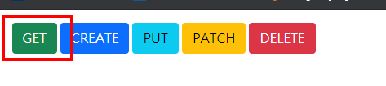const apiEndPoint = "https://jsonplaceholder.typicode.com/posts"

// select DOM elements

const getButton = document.querySelector("#getPost");

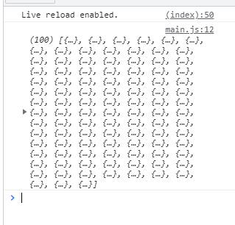const createButton = document.querySelector("#createPost");

const updateButton = document.querySelector("#updatePost");

const patchButton = document.querySelector("#patchPost");

const deleteButton = document.querySelector("#deletePost");

function getPosts() {

fetch(apiEndPoint).then((response) => {

response.json().then((posts) => console.log(posts));

})

}

getButton.addEventListener("click", () => {

getPosts();

})

<div class="col">

......

<button class="btn btn-danger" id="deletePost">DELETE</button>

<div id="table"></div>

</div>

/vanilla/dist/main.js

const apiEndPoint = "https://jsonplaceholder.typicode.com/posts"

// select DOM elements

......

// get posts

const getPosts = async() => {

try{

const response = await fetch(apiEndPoint);

if (response.status != 200){

throw new Error(`Some Error, Status code:${response.status}`);

}

const posts = await response.json();

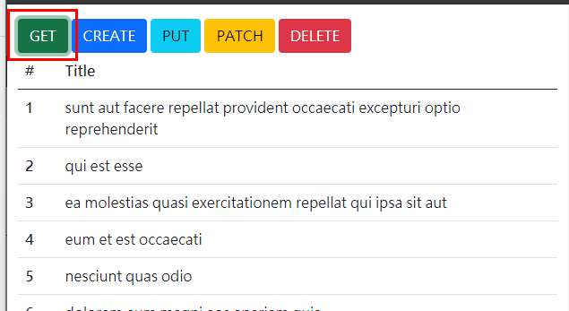 return posts;

} catch (error) {

console.log(error)

}

}

getButton.addEventListener("click", async() => {

const posts = await getPosts();

if(posts){

const table = `

<table class="table">

<thead>

<tr>

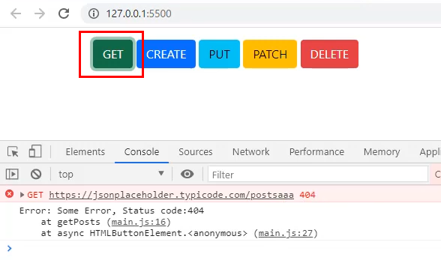 <th scope="col">#</th>

<th scope="col">Title</th>

</tr>

</thead>

<tbody>

**給錯誤的路徑**

${posts.map((post) => `

<tr>

<th scope="row">${post.id}</th>

<td>${post.title}</td>

</tr>

`).join("\n")}

</tbody>

</table>

`;

document.querySelector('#table').innerHTML = table;

}

})

const createPost = async (newpost) => {

try {

const response = await fetch(apiEndPoint, {

method: "POST",

body: JSON.stringify(newpost),

headers: { "Content-type": "application/json; charset=UTF-8" },

});

if(response.status != 201){

throw new Error(`Something went wrong,Status Code: ${response.status}`);

}

const post = await response.json();

return post;

} catch (error) {

console.log(error);

}

}

.....,

createButton.addEventListener("click", async () => {

const newPost = {

title: "New Post Title",

body: "New Post Body",

userId: 1,

};

const createdPost = await createPost(newPost);

console.log(createdPost);

})

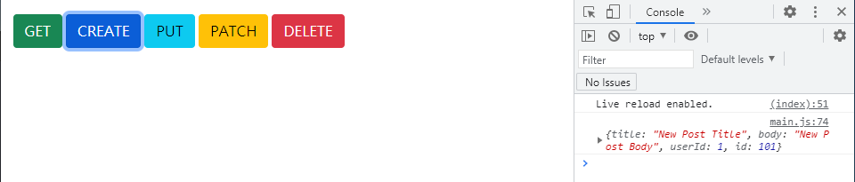

const updatePost = async (newpost,id) => {

try {

const response = await fetch(`${apiEndPoint}/${id}`, {

method: "PUT",

body: JSON.stringify(newpost),

headers: { "Content-type": "application/json; charset=UTF-8" },

});

if(response.status != 200){

throw new Error(`Something went wrong,Status Code: ${response.status}`);

}

const post = await response.json();

return post;

} catch (error) {

console.log(error);

}

}

......

updateButton.addEventListener("click", async () => {

const newPost = {

id: 2,

title: "Updated Post Title",

body: "Updated Post Body",

userId: 1,

};

const updatedPost = await updatePost(newPost,2);

console.log(updatedPost);

})

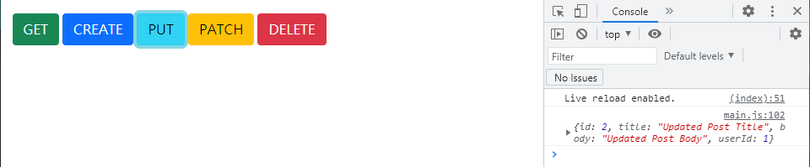

const patchPost = async (newpost,id) => {

try {

const response = await fetch(`${apiEndPoint}/${id}`, {

method: "PATCH",

body: JSON.stringify(newpost),

headers: { "Content-type": "application/json; charset=UTF-8" },

});

if(response.status != 200){

throw new Error(`Something went wrong,Status Code: ${response.status}`);

}

const post = await response.json();

return post;

} catch (error) {

console.log(error);

}

}

patchButton.addEventListener("click", async () => {

const newPost = {

title: "Updated Post Title",

};

const patchedPost = await patchPost(newPost,2);

console.log(patchedPost);

})

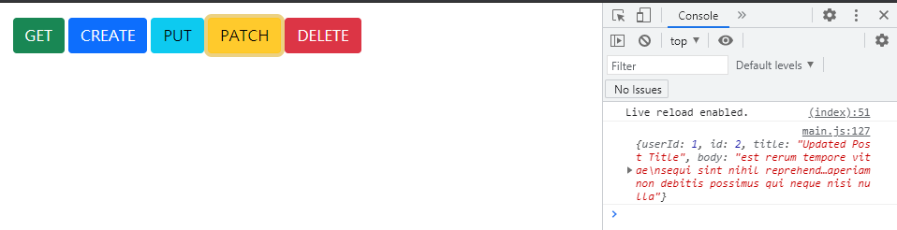

const deletePost = async (id) => {

try {

const response = await fetch(`${apiEndPoint}/${id}`, {

method: "DELETE",

});

if(response.status != 200){

throw new Error(`Something went wrong,Status Code: ${response.status}`);

}

const post = await response.json();

return post;

} catch (error) {

console.log(error);

}

}

deleteButton.addEventListener("click", async () => {

const deletedPost = await deletePost(2);

console.log(deletedPost);

})

